**ASSIGNMENT-4**

**DISTANCE DETECTION USING ULTRASONIC SENSOR**

|  |  |
| --- | --- |
| **Date** | 26 October 2022 |
| **Team ID** | PNT2022TMID24203 |
| **Name & Register Number** | KALLAGUNTA ANILKUMARREDDY(111419106044) |
| **Mark** | 2Marks |

# Question1 :

Write code and connections in wokwi for ultrasonic sensor. Whenever distance is less than 100 cms send "alert" to IBM cloud and display in device recent events

# CODE:

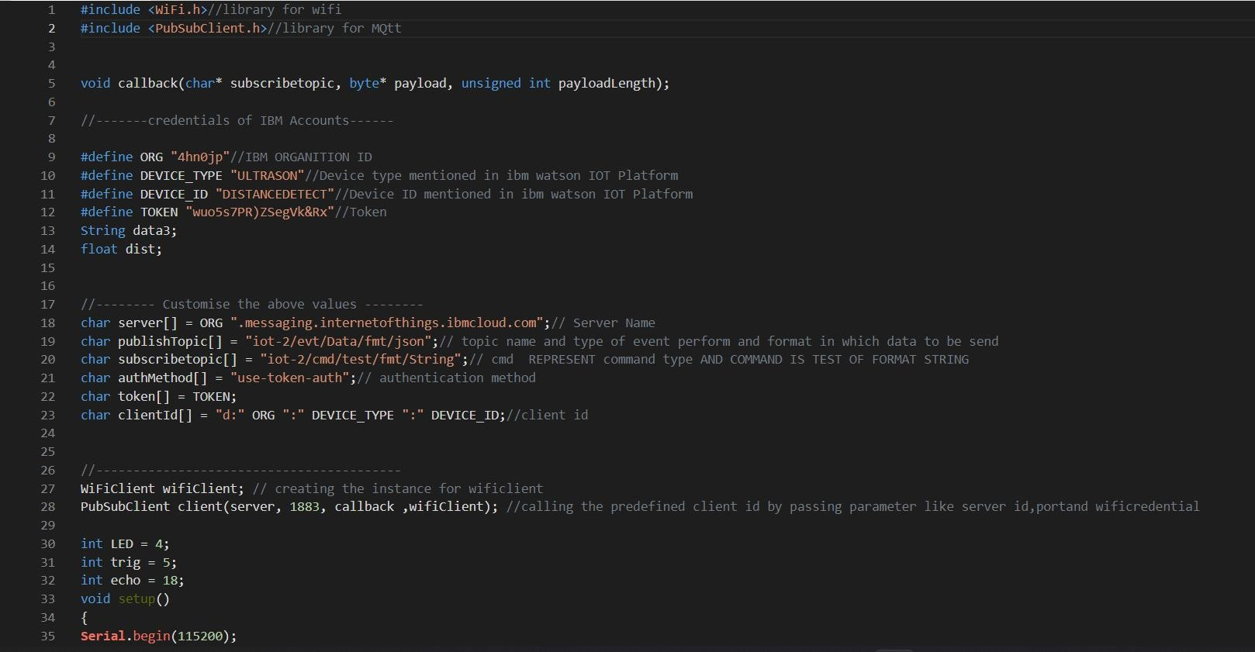

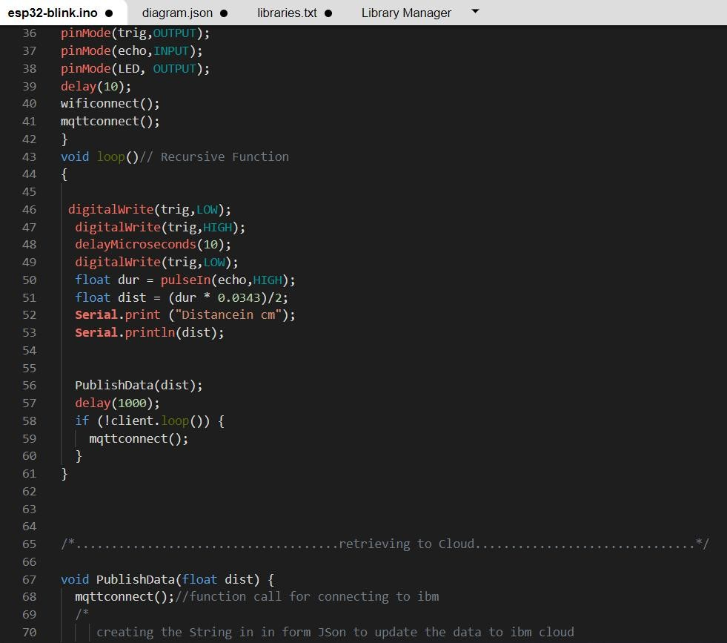

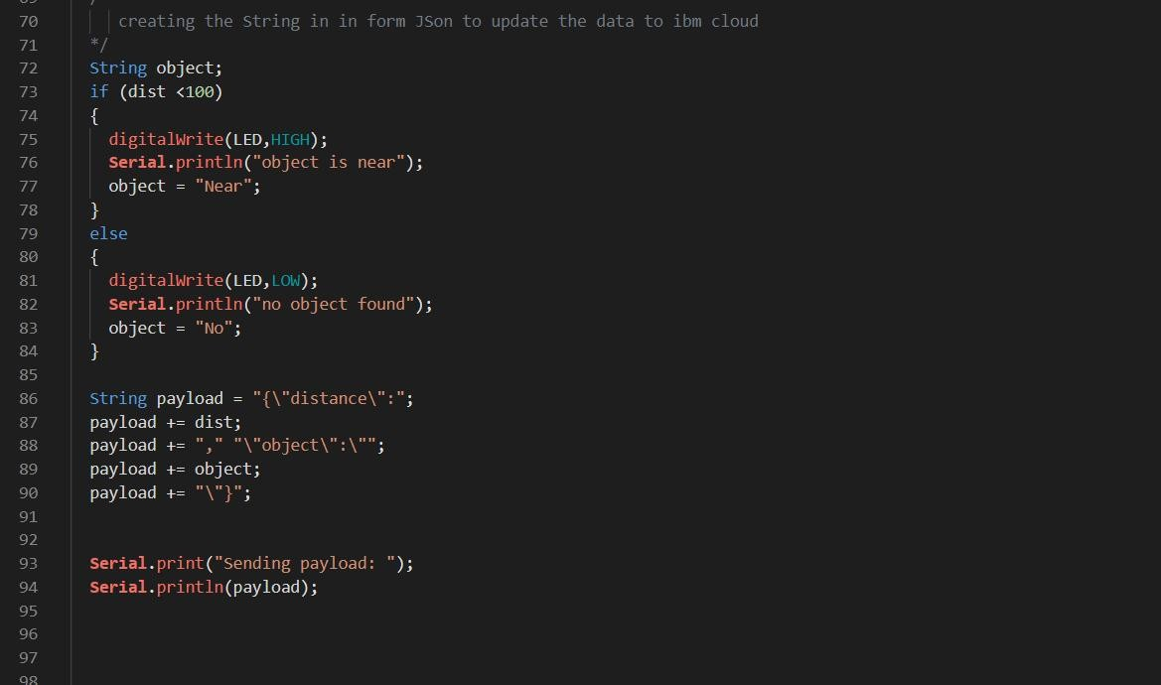

.

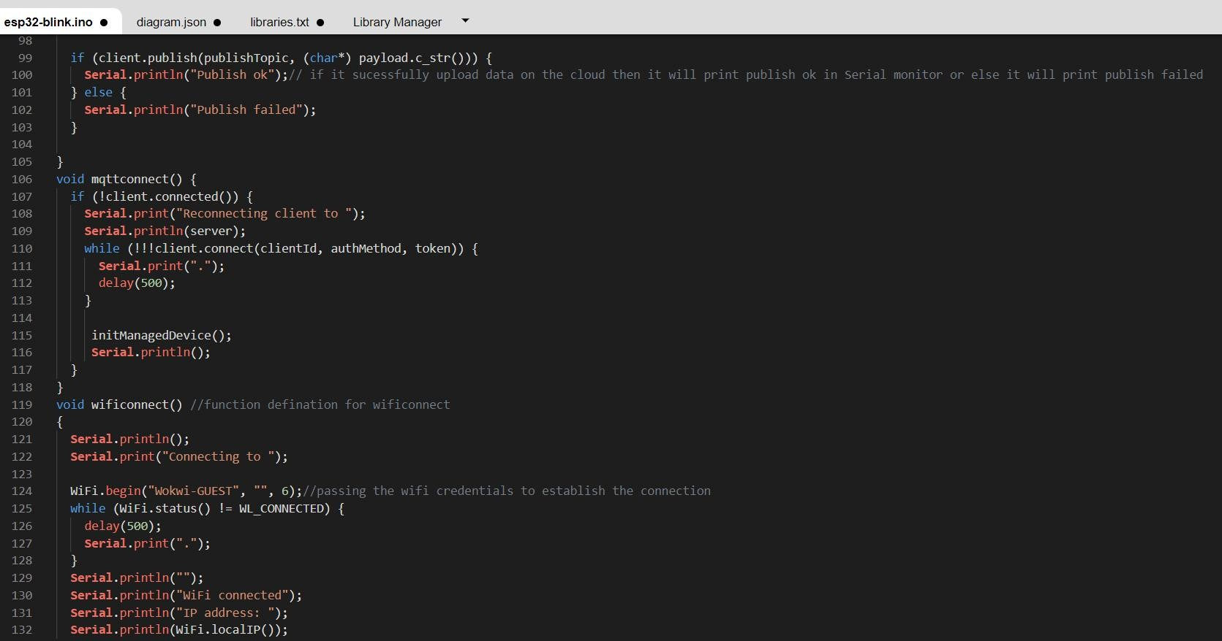

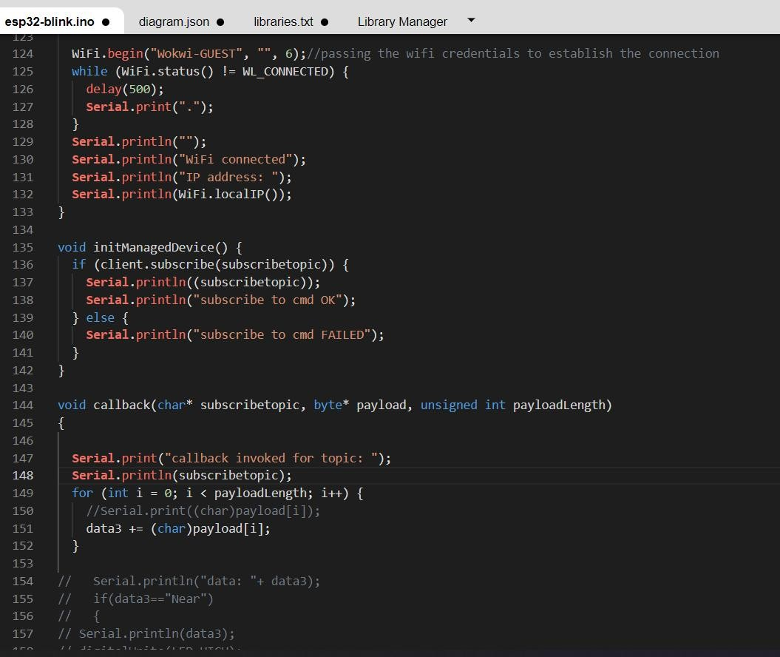

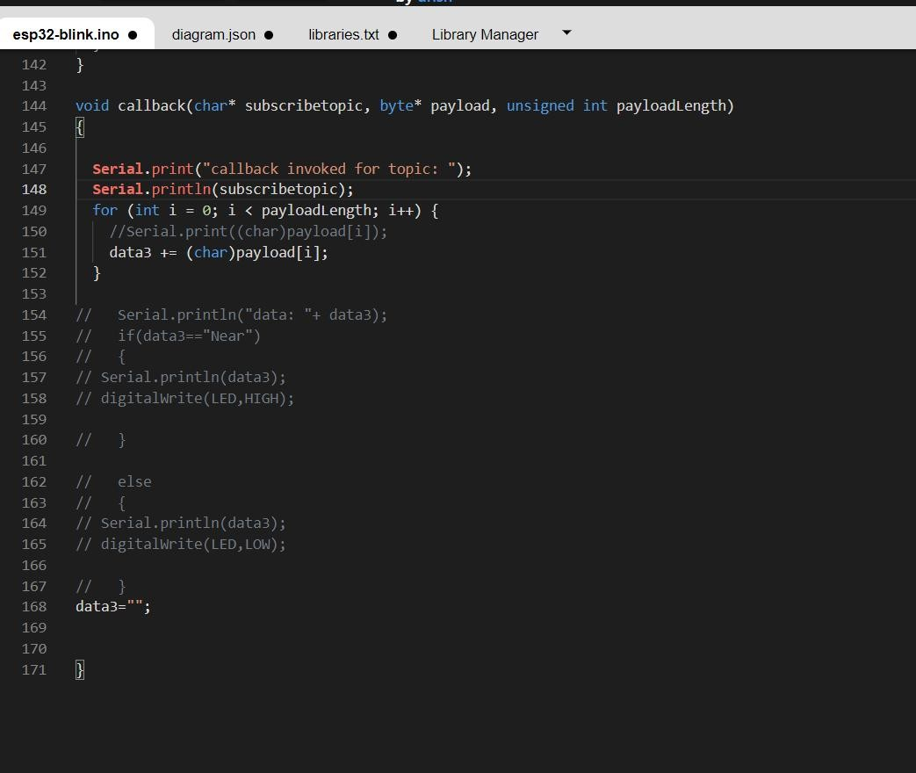

# OUTPUT:

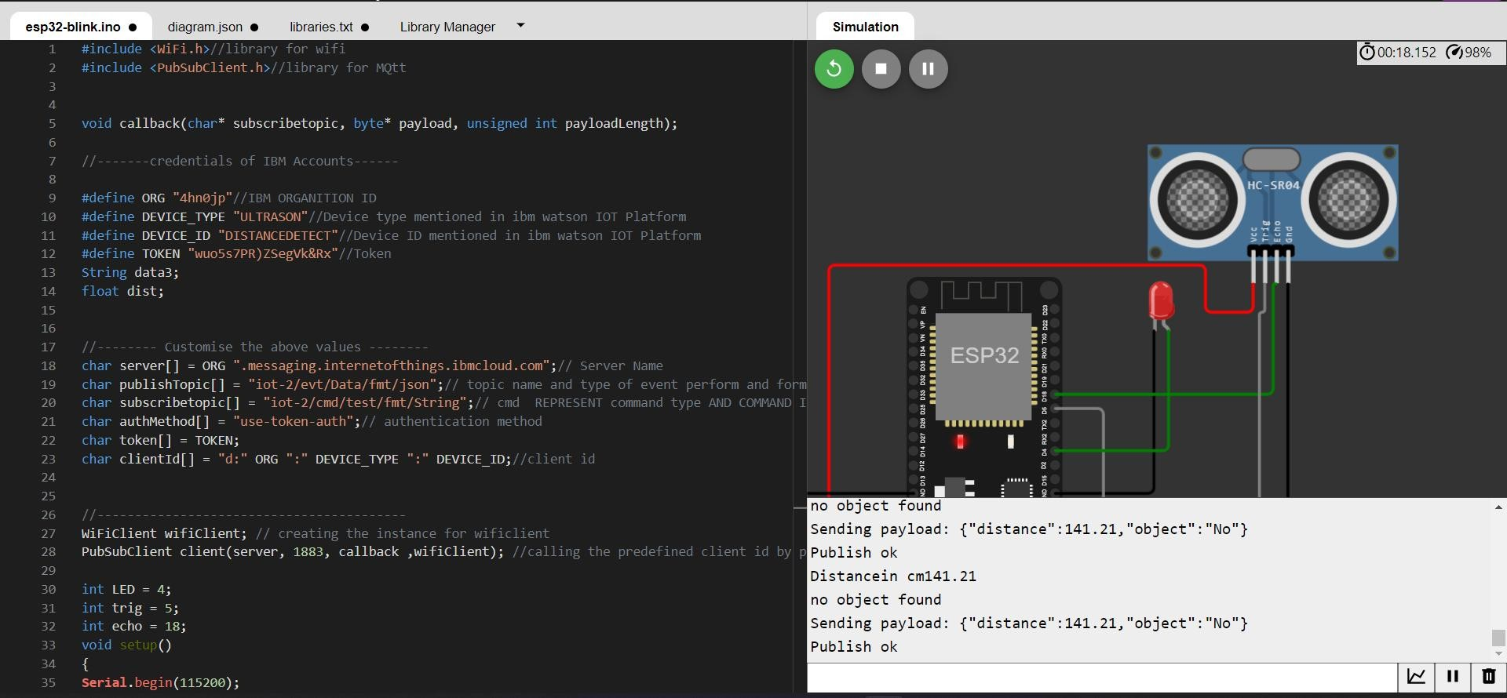

**Data send to the IBM cloud device when the object is far**

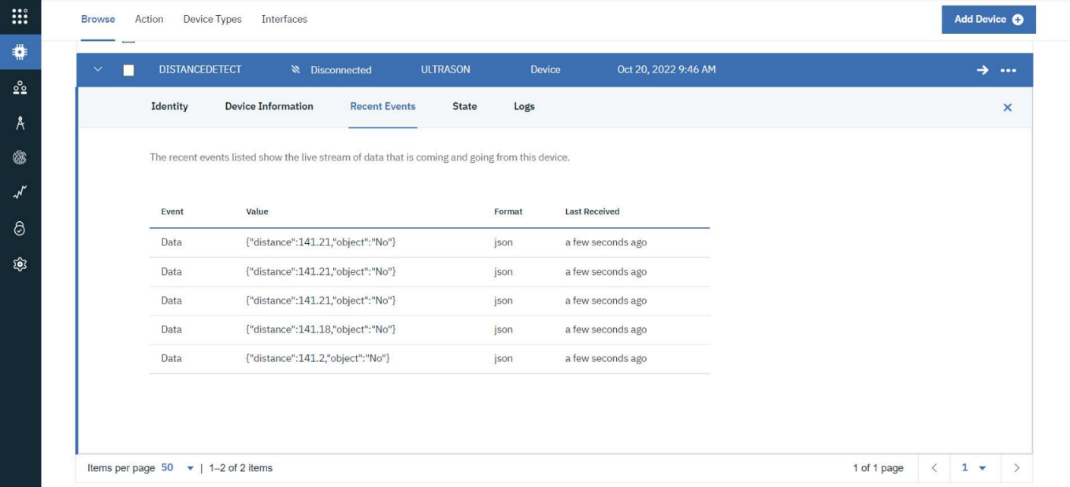

# When object is near to the ultrasonic sensor

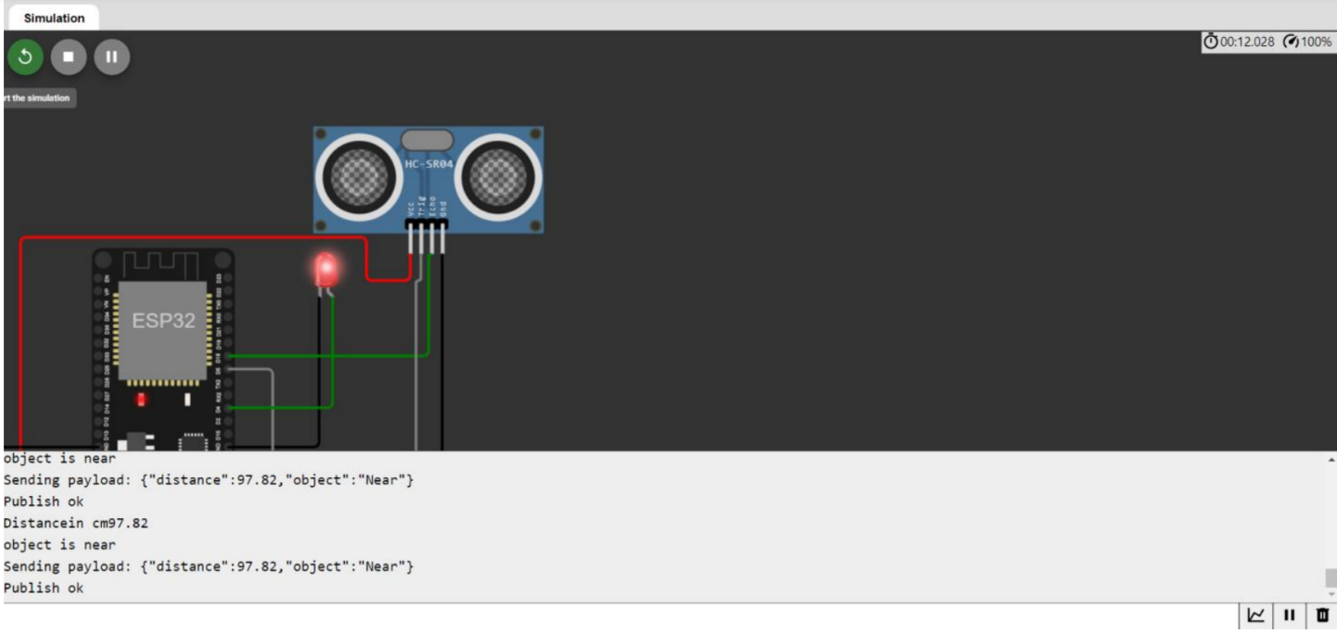

**Data sent to the IBM Cloud Device when the object is near**

